Clean Hands™

The Clean Hands™ Program Comprising More Valid Analysis of Performance and/or Equipment Fitting Toward Unparalleled Improvement

Version 1.0.0

© 2020 WaggleWeight® Company. All rights reserved.

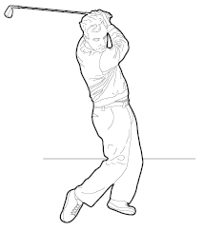
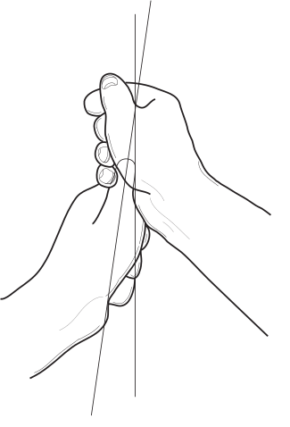

The Clean Hands™ program was largely developed in view of certain aspects of the game of golf that are not typically encountered in most other activities. This is not to say that the concepts involved are only limited to the game of golf, as that is certainly not the case. They are in fact very universal in nature, applying to man trying to excel at any and all activities. But they are just brought to the surface and need to be attended to more in the game of golf due to these aspects, whereas they can broadly and often tend to be taken for granted in other activities.

In view of this, discussions will often naturally tend to reference the game of golf. But make no mistake, the Clean Hands™ protocols are equally valid at achieving unequaled analysis and improvement regarding performing and equipment fitting for all activities to varying degrees (depending upon the specific activity).

Various types of swing analysis devices have been a staple toward attempted improvements in golf swings and clubfitting for as long as various technologies first became available. Yet it seems like no matter how much technology improves, golfers as a whole just do not seem to, at least not to a degree that comes anywhere close to paralleling various technological advances.

Everybody has at one time or another heard the expression that knowledge is power, and it is hard to argue with the expression from most perspectives. Nowhere can this be observed to be truer than in the clubfitting trade, where even as certain more advanced technologies have become available, like launch monitors, basic clubfitting knowledge has actually deteriorated in correctness and broadly become worse among humans within the industry. The trade's performance and reputation have become so bad in recent times that it has contributed to some degree to more people leaving the game. This is certainly proof that the knowledge (or lack thereof) of the humans involved is far more powerful toward the outcome(s) than even the most advanced of technologies to work with.

With this in mind, and despite the proliferation, availability, and affordability to more golfers of swing analyzers, even on a personal level these days, these devices as a general whole have not been able to improve the swings and clubfittings of golfers as much as they otherwise could. This is largely because the way such devices are utilized is typically very faulty by way of insufficient golfer knowledge in critical areas. The Clean Hands™ methodology, based on universal principles that have been around for as long as man has been around but clearly not comprehended acceptably by the golf industry to this point in time, will vastly improve swing and/or clubfitting results for any golfer using his/her own swing analysis device.

Please note that instructions might (or might not depending upon countless various circumstances) further evolve and be updated at any time without express notice given, and could potentially change substantially even over a very short period of time. Various levels of registration can be chosen from based upon such preferences.
Clean Hands™ Registration Information and Personal or Commercial Registration
To Access the Clean Hands™ Operating Instructions for Analysis and Improvement of Performance and Equipment Fitting Please Enter Your Registration Information:

_________________

